# Test Requisition and Billing

MercyOne Des Moines Laboratory provides convenient Test Requisition forms for its clients, which include a pre-printed client address, telephone number and client code. These forms are utilized for ordering laboratory tests as well as providing MercyOne Des Moines Laboratory with important billing and test reporting information.

## **Required Test Request Information**

The following information is required for MercyOne Des Moines Laboratory to properly register, order and bill for lab testing, as well as prevent delays and interruptions to workflow.

* Patient demographics: legal name (first, last and middle initial), date of birth, and sex. **DO NOT** use patient nickname or initials
* Social Security Number or last 4 numbers (preferred but not required)
* Time and date of specimen collection
* Collector/phlebotomist Initials
* Physician’s name (last name and first name)
* Billing Type (Bill Office/Physician, Bill Insurance, or Patient Bill). Please check the appropriate bill type
* Insurance Information (if MercyOne Des Moines Laboratory is Billing Insurance)
* Symptoms or Diagnosis (required for documenting medical necessity for each test ordered)
* Tests to be performed

## **Identifying Patient**

Accurately printing the patient’s **full legal name** and **middle initial** will ensure the patient’s results are included in MercyOne Des Moines Laboratory’s electronic medical record and assist in accurate timely billing. The last 4 numbers of the social security number are preferred to ensure proper identification of the patient. The required fields for identifying the patient on the test request are:

* Legal Name
* Date of Birth
* Sex/Gender
* Social Security # (preferred)

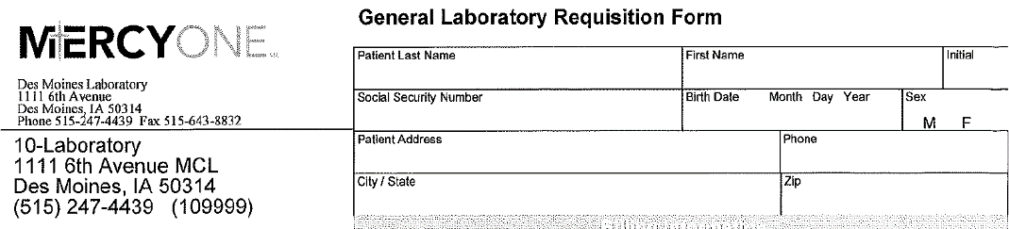

## **Identifying Specimen & Physician**

Submitting the date and time of specimen collection will ensure patient results are included accurately in their longitudinal electronic medical record. The ordering provider’s first and last name is required for proper reporting and billing.

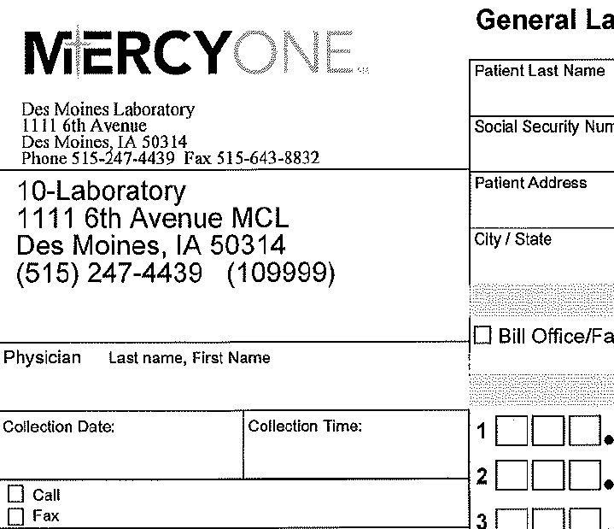

* Provider’s Last Name and First Name
* Collection Date and Time

## **Selection of Billing**

Several billing options are available to MercyOne Des Moines Laboratory clients. MercyOne Des Moines Laboratory Billing Representatives are available to discuss which option best suits your needs or the requirements of the insurance companies.

Selecting a billing option by marking the appropriate box and providing the necessary diagnosis information is required for MercyOne Des Moines Laboratory to accurately bill.

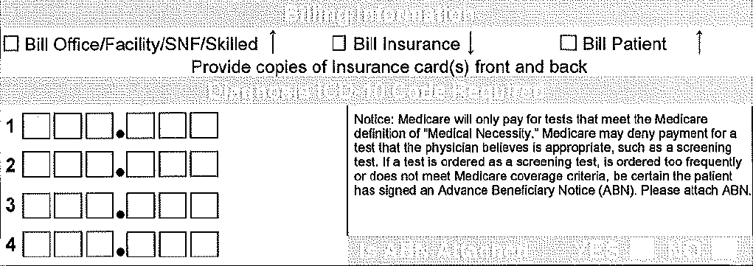

* Select Billing Option
* Enter Diagnosis ICD-10 Code(s)
* Include appropriate insurance information

### 

### Billing Options: MercyOne Des Moines Laboratory Clients have three options for the billing of laboratory tests.

1. Bill Physician/Office/Client (MercyOne Des Moines Laboratory bills the health care provider)
   1. Bills are printed and sent monthly. Questions can be resolved by contacting the MercyOne Des Moines Laboratory Billing Representative at (515) 643-2326.
   2. If Bill Office/Client is chosen, section one of the test request form must be completed. Clients then receive a monthly, itemized invoice for MercyOne Des Moines Laboratory services provided. All invoices are due in full upon receipt and must be paid within 30 days from the date billed. Any charges unpaid after 30 days are subject to an increase of 1.5% per month (both before and after judgment) and continuing each month until paid. Charges still outstanding after 90 days from invoice date are subject to collection and all collection or arbitration expenses, attorney’s fees, and court costs will be borne by the purchaser. All claims, requests for adjustment, or notification of errors must be made within 30 days or charges are considered acceptable.
2. Bill Insurance (MercyOne Des Moines Laboratory bills the patient’s insurance)
   1. MercyOne Des Moines Laboratory test request must be completed with current insurance information or attach complete information such as a copy of both sides of the patient’s insurance card or a printout that includes this information.
   2. Enter Subscriber Name in the Bill Insurance box.
   3. Enter Guarantor Information if the patient is under 18 years old.
   4. Please be sure to include insurance information for Medicare HMOs when appropriate.
   5. For patients with Medipass insurance, you must also provide the Medipass doctor number on the test request in the PCP NPI box. The NPI may carry over into the Bill Office/Physician box.
   6. If Bill Insurance is chosen, the client is responsible for providing all current billing information. Complete sections one and two of the test request form or attach encounter form to the requisition. MercyOne Des Moines Laboratory will submit the charges to the designated insurance for payment.
3. Bill Patient (MercyOne Des Moines Laboratory bills the patient)
   1. Must be completed with the patient’s current address and telephone number in order to allow appropriate billing.
   2. If Bill Patient is chosen, the client is responsible for providing necessary patient and payer information as required in sections one and two. Collection of payment becomes the responsibility of MercyOne Des Moines Laboratory.

Changes to a client’s bill must be submitted on a MercyOne Des Moines Laboratory Billing Change Form. Adjustments to the client’s bill will be reflected on the next billing cycle. Payments should be made for the amount originally billed. The client’s bill will then be adjusted on the month after the Billing Change Form is received. Please contact MercyOne Des Moines Laboratory Client Services for a supply of Billing Change forms.

## **Symptoms or Diagnosis Information**

**Diagnosis to support testing is a requirement for a valid order.** MercyOne Des Moines Laboratory is required by payers (including Medicare) to submit ICD-10 codes of the patient’s symptoms, illness or complaint with each claim. Our billing staff may contact you via fax or phone to obtain additional information, if necessary.

## **Other Information**

* Mark requisition as Fasting or Non Fasting
* Complete Special Reporting box if testing is to be expedited or requested to call or fax results.
* Mark appropriately if ABN attached.
* Clients do not need to complete the CPI#, MRN#, initial IBM, or initial Cern.
* For cytology and histology specimen types, the corresponding requisition requires additional clinical analysis for a complete analysis of the specimen. See Cytology Collection specifics and Histology Collection specifics.

## **Selection of Tests**

* Most commonly ordered tests appear on the test requests. To order, clearly check the box next to the test.
* Tests offered in any MercyOne Des Moines Laboratory panel or profile may be ordered individually using the MercyOne Des Moines Laboratory test request.
* If a desired test is not listed on the test request, please legibly write the tests in the “Additional Tests” section of the test request. MercyOne Des Moines Laboratory staff will call for clarification on tests that are not legible or if an uncommon abbreviation is used.
* The CPT Codes provided are based on AMA Guidelines and are for informational purposes only. CPT Coding is the sole responsibility of the billing party. Please direct any questions regarding CPT Coding to the payer being billed.
* All orders must be in writing and delivered with the specimen or faxed in advance. An electronic order is accepted using appropriate Mercy computer systems. MercyOne Des Moines Laboratory does not accept verbal or e-mail orders.
* Please send one copy of the provider’s order. Multiple copies of the same order that are inconsistent will need clarification from your office. This may result in delay in testing.