  
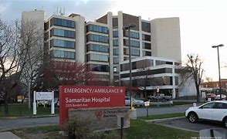

Samaritan Troy, NY

FirstChoice Orientation Guide

**Hospital Information**

2215 Burdett Ave, Troy, NY 12180

350 bed hospital

6 Adult inpatient units

1 Adult ICU

Behavioral Health unit

Emergency Center

Surgery Center

**Scrub Color**

* RN – Wine top, black or wine bottoms, wine coat

**Parking Information**

* SPH & SAM – Main parking garage
* SVH – Main lot

**First Day Information**

Email sent to new hire week before start with instructions and next steps

**Badging**

Pick up badge at SPH security office on first day

**Employee Health Contact**

(518) 525-2360

**Onboarding Contact for FirstChoice**

Tonya Wingate | tonya.wingate@trinity-health.org

**PPE Provided**

Surgical mask, face shield, N95, gown, PAPRS, gloves (depends on patient's diagnosis)

**Patient to Nurse Ratio**

ICU 1:2, SDU 1:3, Card Tele-1:4 M/S-1:5 (1:6 on nights)

**Shifts Offered**

Mainly 12, some departments offer 8

**Key Contacts**

* Mario Irizarry | MGR – Nurse Acute Clinical Resource Pool | mario.irizarry@sphp.com |
* Kim Houlihan [<Kim.Houlihan001@sphp.com](mailto:<Kim.Houlihan001@sphp.com)> Nurse Supervisor
* Crystal Ramayya | Administrative Assistant Clinical Resource Pool | CRYSTAL.RAMAYY@sphp.com

**Lunch Room Options**

Each facility has a café, and each unit has a breakroom

