

Mercy Health Saint Mary's Grand Rapids

FirstChoice Orientation Guide

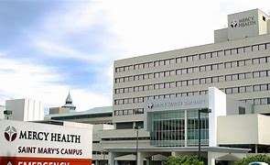



**Scrub Color**

* RN – Hunter Green
* RT – Pewter Grey

**Hospital Information**

200 Jefferson Ave SE, Grand Rapids, MI 49503

303 Bed Hospital

Level 2 Trauma Center

6 Inpatient Units

1 Adult ICU

Birthing Center

Surgical Services Center (OR/PACU)

Emergency Center

Charting - EPIC

**First Day Information**

* See Security (07-1530 M-F) for badge and parking instructions
* Report to assigned Unit
* It is beneficial on day 1 if you can come in ahead of time (day or 2 prior) for badge/parking assignment
* Ensure EPIC education is completed prior to 1st day

**Employee Health Contact**

(616) 685-3150

**Onboarding Contact for FirstChoice**

* Mercy Health Saint Mary’s Staffing (616) 685-6427 – ill calls and in the moment needs
* FirstChoice Staffing Office 734-398-8771 – Must call both locations for ill calls

**PPE Provided**

Varies based on patient needs

**Patient to Nurse Ratio**

Varies based on patient acuity/needs

**Shifts Offered**

* 8 Hour Shifts:  07-1530 / 15-2330 / 23-0730
* 12 Hour Shifts:  07-1930 / 19-0730

**Key Contacts**

* Security Services (616) 685-6500 (Main) | (616) 685-6180 (ED)
* Main Hospital 616-685-5000
* Staffing Office (734) 398-8779

**Lunch Room Options**

* Varies based on unit, charge nurse is the best resource
* The hospital has a cafeteria

