

Holy Cross Hospital

FirstChoice Orientation Guide

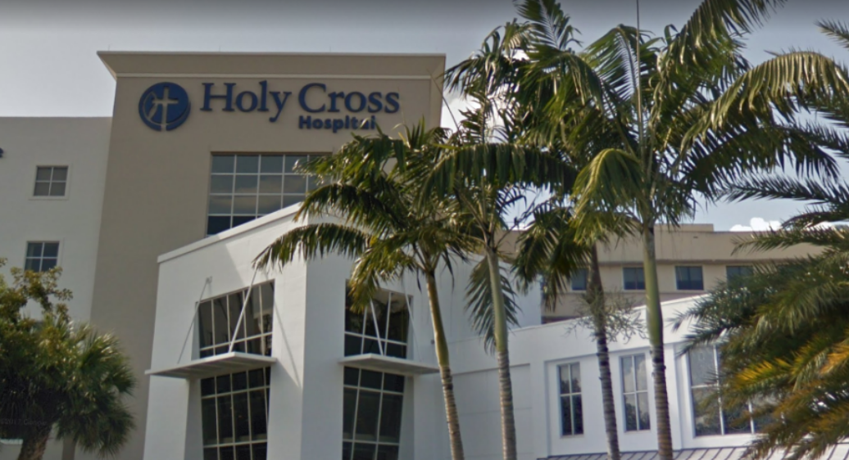

**Scrub Color**

* ED Ceil Blue
* RT Royal Blue
* CVICU Ceil Blue
* IMC/Stepdown Ceil Blue

**Hospital Information**

4725 N Federal Hwy, Fort Lauderdale, FL 33308

367 Bed Hospital

Emergency Department (Geriatric-certified, non-trauma)

6 Inpatient Units (Intensive Rehab Unit, Intermediate Care Unit, Surgical Telemetry, Orthopedics,

Cardiovascular Intermediate Care Unit, Telemetry)

3 Critical Care Units Cardiovascular ICU, Neurosurgical ICU, Coronary Care Unit

Surgery Center Holy Cross Healthplex

**Key Contacts**

* Occupational Health 954-229-8666
* Associate Health Office 954-492-5794
* Onboarding Contact for FC and work hours, Karla Harper 954-267-6946

**ED** **Nurse Manager**

Rich Van Ransselaer, (954)351-7830, [Richard.VanRensselaer@holy-cross.com](mailto:Richard.VanRensselaer@holy-cross.com)

**Assistant Nurse Managers**

David Greene, (954)864-0631 [David.Greene@holy-cross.com](mailto:David.Greene@holy-cross.com)

Starr Oiestad, (954)552-4392, [starr.oiestad@holy-cross.com](mailto:starr.oiestad@holy-cross.com)

**RT** Andrea Scott, RT Manager, (954)776-3181, [Andrea.MacDonald@holy-cross.com](mailto:Andrea.MacDonald@holy-cross.com)

James Cater, RT Supervisor, (954)771-8000 x5525, [James.Cater@holy-cross.com](mailto:James.Cater@holy-cross.com)

**Critical Care** **Nurse Manager**

Simone Atkinson, (954)351-5980, [Simone.Atkinson@holy-cross.com](mailto:Simone.Atkinson@holy-cross.com)

**Assistant Nurse Managers**

Beverly Nowlan, (954)267-6609, [Beverly.Nowlan@holy-cross.com](mailto:Beverly.Nowlan@holy-cross.com)

Kaleigh Dycus, [kaleigh.dycus@holy-cross.com](mailto:kaleigh.dycus@holy-cross.com)

**IMC** **Nurse Manager**

Kimone Josephs, IMC Nurse Manager, (954)776-3018, Kimone.Josephs@holy-cross.com

**Assistant Nurse Manager**

Paige Phillips, IMC Assistant Nurse Manager- (954)445-1486, [paige.phillips@holy-cross.com](mailto:paige.phillips@holy-cross.com)

**Telemetry Nurse Manager**

Amy Senne, Telemetry Nurse Manager, (954)776-3079, [amy.senne@holy-cross.com](mailto:amy.senne@holy-cross.com)

**Assistant Nurse Manager**

Min Alcorn, Telemetry, (954)258-8254, [herminia.alcorn@holy-cross.com](mailto:herminia.alcorn@holy-cross.com)

Annella Torrente, CVIMC, (954)461-8999, [annella.torrente@holy-cross.com](mailto:annella.torrente@holy-cross.com)

**4-South**  **Nurse Manager**

Michael Grenier, (954)882-5341, [michael.grenier@holy-cross.com](mailto:michael.grenier@holy-cross.com)

**Assistant Nurse Managers**

Antonette Silvis, [antonette.silvis@holy-cross.com](mailto:antonette.silvis@holy-cross.com)

**PPE Provided**

ED PPE shields, masks, N95

RT Masks (N95 + surgical), gowns, gloves, face shield

CVICU Per guidelines and recommendations of the CDC

IMC/Stepdown N95 mask, surgical mask, gown, face shield, goggles

**Patient to Nurse Ratio**

ED 4-1 in all units except fast track which is 6-1

RT RT vent count 4-5, treatment counts 45 in 12 hrs

CVICU Dependent upon acuity of the patients/surge

IMC/Stepdown 5 patients; goal is 4 but depending on patient acuity that they may have 3 patients max

Telemetry 1:5-6

Med-Surg 1”6-7 (7 on nights only)

**EMR** Meditech – Changing to EPIC 10/29/22

**Shifts Offered** 12 hour shifts

**Lunch Room Options**

* All units have break rooms and lounges
* Cafeteria open 0600-1830
* “Holy Crossings” - self-service lounge near main entrance with pre-made salads, sandwiches, drinks, hot coffee, snacks
  + Massage chair lounge

