  
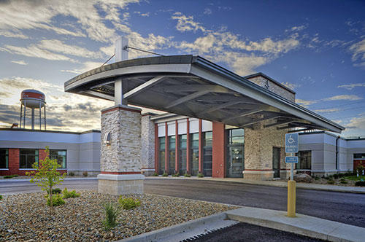

MercyOne New Hampton Medical Center – New Hampton, IA

FirstChoice Information Guide

**Hospital Information**

308 N Maple Ave, New Hampton, IA 50659

Cares for 20,000 outpatients each year

11 Private Inpatient Rooms

Emergency Services

Surgical Services

**Scrub Color**

RT – Wine

CST – Scrubs Provided

OR RN – Scrubs Provided

RN - Navy

**Regional FirstChoice Contacts**

Megan Quam megan.quam@mercyhealth.com

**Parking Information**



**Badging**

Photo taken day 1 and would receive their badge later that same day.

**Onboarding Contact for FirstChoice**

**TAP: Janan Savaya** [janan.savaya@trinity-health.org](mailto:janan.savaya@trinity-health.org) / 734-343-0728

TAC: Jill C. Vautrin [Jill.Vautrin@trinity-health.org](mailto:Jill.Vautrin@trinity-health.org)

**PPE Provided**

Masks, gloves, gowns, shields, etc. (depends on location assigned)

**Patient to Nurse Ratio**

**RN to Patient Ratios:**

*Med Surg* is 6:1 with team of 1 RN, 1 LPN, and a NA but if not enough staff to do team nursing then 4 to 1 days and 5:1 nights.

*ED –* 3 to 1

**Shifts Offered**

12-hour shifts