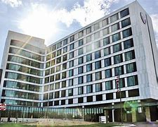  


Mercy Health Muskegon

FirstChoice Orientation Guide

**Scrub Color**

* RN – Pewter Grey
* RT – Hunter Green

**Hospital Information**

1500 E Sherman Boulevard, Muskegon, MI 49444

409 Bed Hospital

Level 2 Trauma Emergency Center

11 Inpatient Units

1 Adult ICU

Birthing Center

Surgical Services Center (OR/CVOR/PACU/UCU/ENDO)

Charting - EPIC

**Badging**

Photo taken during EHS visit in Muskegon, pick up in security/badging office & Central Tracker. Central Tracker must be returned upon completion.

**Employee Health Contact**

(231) 672-4360

**PPE Provided**

Varies based on patient needs

**Patient to Nurse Ratio**

Varies based on patient acuity/needs

**Key Contacts**

* Staffing Office (734) 398-8779

**Lunch Room Options**

Break rooms and/or cafeteria, various options per location

