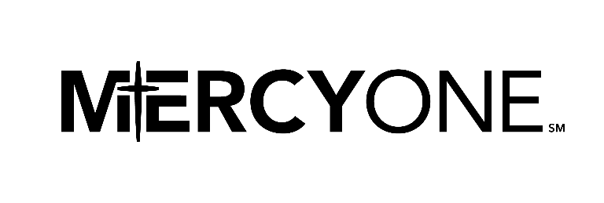

**Friends of MercyOne Oelwein CNA Scholarship**

Each year Friends of MercyOne offer two CNA scholarships to students attending Oelwein High School, West Central High School, Starmont High School, Wapsie Valley High School, as well as MercyOne Oelwein Medical Center colleagues. The purpose of these scholarships is to assist anyone interested in becoming a Certified Nursing Aid (CNA) by being used to cover the associated costs of tuition and testing. The amount of the award is equal to the course tuition not to exceed $700 dollars. Upon receiving the CNA scholarship, the recipient would make a commitment to work at MercyOne Oelwein Medical Center for at least three months.

**Eligibility Requirements:**

1. High school student must be in good academic standing at their high school and attach a copy of their high school transcript.
2. If not a high school student, the applicant must be a colleague of MercyOne.
3. Student must be 16 years of age before the course is scheduled to start.
4. Applicant must meet hiring criteria of MercyOne.
5. Applications will be coordinated with CNA course training as training becomes available.
6. Scholarships must be used within one year of award. Funds not used will be released for the use of others.

**Terms of Scholarship:**

* Scholarship funds will be paid to the educational institution, not to the scholarship recipient.
* Selection is based on the following criteria:
  + Fully completed scholarship application
  + Personal qualities (as described by references)
  + Strength of explanation as to why they should be the scholarship recipient

**All applicant information is confidential**

* Please return the fully completed application to:  
  Friends of MercyOne Oelwein, CNA Scholarship  
  c/o MercyOne Oelwein Medical Center  
  201 8th Avenue SE  
  Oelwein, IA 50662

For any questions email Dawn Kendall: cdmcken@hotmail.ciom or call at 319-283-1051