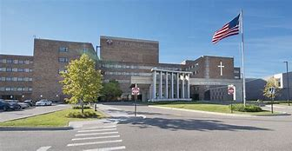  


ST. MARY MERCY LIVONIA

FirstChoice Orientation Guide

**Scrub Color**

* RN – Navy Blue
* RT – Maroon/Cranberry

**Hospital Information**

36475 Five Mile Rd, Livonia, MI 48154

304 Bed Hospital

8 Inpatient Units

1 Adult ICU

Birthing Center

Level 2 Trauma Center

Mercy Health Emergency Southwest

Surgical Services Center (OR/PACU/ENDO)

Charting - EPIC

**Parking Information**

North Lot (Off 5 Mile)

**Badging**

On first day go to security/badging office to obtain badge.

**Employee Health Contact**

(734) 712-3297

**PPE Provided**

Varies based on patient needs

**Patient to Nurse Ratio**

Varies based on patient acuity/needs

**Key Contacts**

* Staffing Office (734) 398-8771
* RT Manager- Michael Hickman (734) 655-3992
* RT Dayshift Charges - Julie Adams and Cindy Hedeed (734) 655-2924

**Lunch Room Options**

Break rooms and/or cafeteria, various options per location

