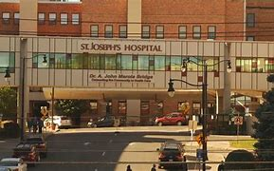  


St. Joseph Hospital Health Center – Syracuse, NY

FirstChoice Orientation Guide

**Scrub Color**

* RN – Navy Blue
* RT – Royal Blue

**Hospital Information**

104 Union Ave, Syracuse, NY 13203

431 Bed Teaching Hospital

12 Adult Inpatient Units

2 Adult ICUs (CVICU, MSICU)

NICU

Birthing Center

Surgical Center (CVOR, OR, PACU, ENDO)

Emergency Center including Psychiatric Emergency Center

**Parking Information**

* $3 per week, can pay by the week
* 13 week assignments pay $39 on day 1 and receive parking pass with lot information

**Badging**

Will receive badge on first day

**Employee Health Contact**

Mary Olson, [Mary.Olson@sjhsyr.org](mailto:Mary.Olson@sjhsyr.org), 315-448-5498

**PPE Provided**

Per CDC, and NYS Regulatory Guidelines for maximum patient and colleague safety.

**Patient to Nurse Ratio**

New model developing.  Based on acuity, unit and skill set.

**Shifts Offered**

12 hour shifts

**Key Contacts**

* Regional FirstChoice Manager Christine K. Whitmore <Christine.Whitmore@sjhsyr.org>
* Capacity Manager Tonya C. Martinez <TONYA.MARTINEZ@sjhsyr.org>
* Nursing Float Coordinator Courtney Shoales <Courtney.Shoales@sjhsyr.org>

**Lunch Room Options**

Varies based on unit worked, main cafeteria and 2 other café options on campus

