  
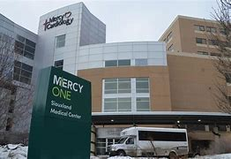

MercyOne Siouxland Medical Center – Sioux City, IA

FirstChoice Information Guide

**Hospital Information**

810 5th St, Sioux City, IA 51101

201 bed hospital

6 Adult inpatient units

1 Adult ICU

Behavioral Health Unit

Surgery Center

Level II Trauma Center – New ER with Fast Track

EMR - Cerner

**Scrub Color**

RN – Navy Blue or White

RT – Black



**Regional FirstChoice Contacts**

Erin Boomsma 712-279-2639 / [erin.boomsma@mercyhealth.com](mailto:erin.boomsma@mercyhealth.com)

**Parking Information**

Parking is onsite and is overlooked by Security

**Badging**

Badges are completed on the colleagues' first day. HR creates them and adds access.

**Onboarding Contact for FirstChoice**

**TAP: Janan Savaya** [janan.savaya@trinity-health.org](mailto:janan.savaya@trinity-health.org) / 734-343-0728

TAC: Jill C. Vautrin [Jill.Vautrin@trinity-health.org](mailto:Jill.Vautrin@trinity-health.org)

**PPE Provided**

Masks, gloves, gowns, shields, etc. (depends on location assigned)

**Patient to Nurse Ratio**

**RN to Patient Ratios:**

**Shifts Offered**

12 hour shifts