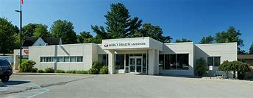  


Mercy Health Lakeshore Campus

FirstChoice Orientation Guide

**Scrub Color**

* RN – Pewter Grey
* RT – Hunter Green

**Hospital Information**

72 S. State St, Shelby, MI 49455

Small Rural Critical Access Hospital

Level 4 Trauma Emergency Center

1 Med/Surg Unit

Surgical Services Center (OR/PACU)

Charting - EPIC

**Badging**

Photo taken during EHS visit in Muskegon, pick up in security/badging office.

**Employee Health Contact**

(231) 672-4360

**PPE Provided**

Varies based on patient needs

**Patient to Nurse Ratio**

Varies based on patient acuity/needs

**Key Contacts**

* Staffing Office (734) 398-8779

**Lunch Room Options**

Break rooms and/or cafeteria, various options per location

