

St. Joseph Regional Medical Center – Mishawaka Indiana

FirstChoice Orientation Guide

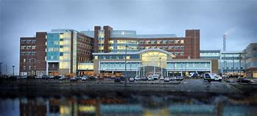

**Scrub Color**

RT Navy blue

RN Royal blue or royal blue/white

Maternal Child Health RNs – Black and pink

Pediatric Dept – Black and Pink or a child friendly theme styled scrub top

**Hospital Information**

5215 Holy Cross Parkway, Mishawaka, IN 46545

293 Bed Teaching Hospital

6 Adult Inpatient Units (4 Med-Surg and 2 Step Down)

2 Adult ICU’s (SICU and ICU)

1 Pediatric unit

NICU

Birthing Center

Surgery Center

Emergency Center

**EMR**

Epic (classroom training provided if not already attended)

**Parking Information**

* Employee parking is clearly identified on both the Mishawaka and Plymouth Campuses (see map below)
* No costs for parking

**Key Contacts**

House supervisor 574-335-7000

Jessica Erlacher First Choice Manager, Jessica.Erlacher@sjrmc.com, 574-335-2575

**First Day Information**

Meet with unit Manager/Supervisor. ORT To hospital and unit.

**Employee Health Contact**

Mishawaka 574-335-1030

**PPE Provided**

Surgical or cloth mask – N95, face shields, gowns, gloves, CAPR

**Patient to Nurse Ratio**

Med surg 1:5-6 on days 1:6-7 nights, Step down 1:3-4 days and nights, ICU 1:1-2

**Shifts Offered**

12-hour shifts, some areas such as perioperative may offer alternative shift options.

**Lunchroom Options**

Breakrooms are on the units. We have a cafeteria and vending machines within each hospital. The Mishawaka Campus also has a micro mart (available 24 hours a day).

