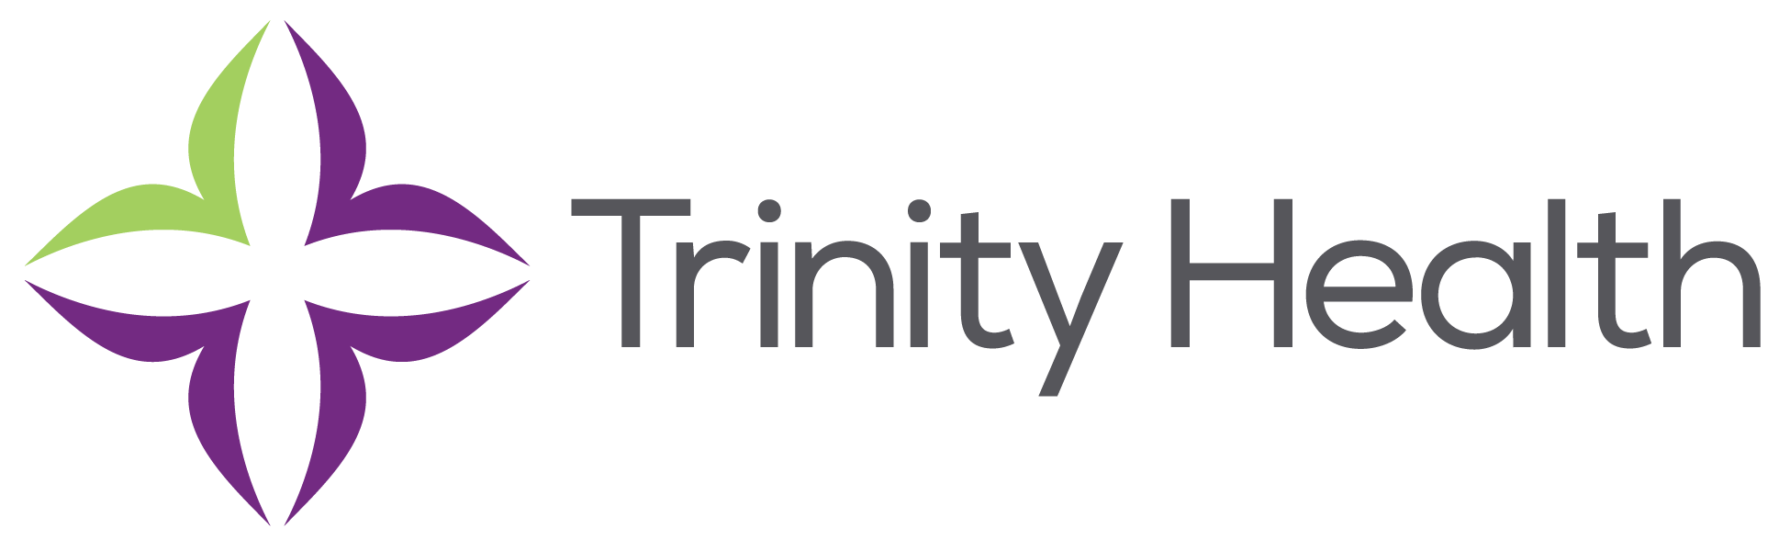

St. Mary’s Sacred Heart Hospital- Lavonia, GA

FirstChoice Information Guide



**Scrub Color**

* RN Navy Blue
* RT Galaxy Blue

**Hospital Information**

367 Clear Creek Pkwy, Lavonia, GA 30553

56 staffed bed hospital

1 Adult ICU

1 Med/Surg unit

Birthing Center

Emergency Center – Level 2 Trauma

4 – Surgical Suites

EMR – CPSI– Transitioning to EPIC October 2022

**Key Contacts**

* Ann Gomes FirstChoice Regional Manager 706-389-3247 Office and Cell 706-340-5891
* Nanci Nix Education Coordinator nanci.nix@stmarysathens.org

**Inpatient Nurse Ratio’s:**

ICU – 2:1

MS – 1:5 day shift, 1:6 night shift

**PPE Provided**

ED PPE shields, masks, N95

RT Masks (N95 + surgical), gowns, gloves, face shield