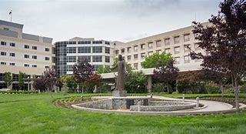   


Saint Agnes Medical Center

FirstChoice Orientation Guide

**Scrub Color**

No black or denim

**Parking Information**

Parking garage – will meet with security

**First Day Information**

Arrive in HR by 7:45 AM – building 5 on map below

**Hospital Information**

1303 E. Herndon Ave, Fresno, CA 93720

436 Bed Teaching Hospital

6 Adult Inpatient Units

2 Adult ICU’s (CVICU and ICU)

Birthing Center – Only Baby Friendly designated facility in Central Valley

Surgery Center

Emergency Center – Stroke, Stemi, and High-Risk OB Receiving Facility (Not a designated Trauma Center)

**Badging**

Will receive at first day HR appointment

**Employee Health Contact**

Occupational Health 559-450-7777

**Onboarding Contact for FirstChoice**

Alison Millhollen – [Alison.millhollen@samc.com](mailto:Alison.millhollen@samc.com)

**PPE Provided**

All necessary PPE is provided – will be fit tested prior to start as part of pre-employment onboarding

**Patient to Nurse Ratio**

ED Size – 44 treatment beds

Patient ratio – based on assigned unit

Nurses float all units and as assigned

**Shifts Offered**

12 hour shifts – some Surgery positions will be 10 hour shifts

