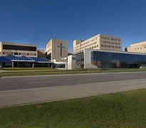  


St. Joseph Mercy Oakland

FirstChoice Orientation Guide

**Scrub Color**

* RN – Royal Blue
* RT – Navy Blue Pants and Ceil Blue Top

**Hospital Information**

44405 Woodward Ave, Pontiac, MI 48341

497 Bed Teaching Hospital

Level 2 Trauma Emergency Center

Birthing Center

10 Inpatient Units

2 Adult ICU’s

Surgical Services Center (OR/PACU)

Charting - EPIC

**Badging**

On first day go to security/badging office to obtain badge & Central Tracker. Central Tracker must be returned upon completion.

**Employee Health Contact**

(248) 858-6003

**PPE Provided**

Varies based on patient needs

**Patient to Nurse Ratio**

Varies based on patient acuity/needs

**Key Contacts**

* Staffing Office (734) 398-8771

**Lunch Room Options**

Break rooms and/or cafeteria, various options per location

