**HealthStream** – this program is located on your computer in the Zen Works window and is accessed by clicking on the HealthStream icon. HealthStream is our on-line learning program for new and current colleagues.

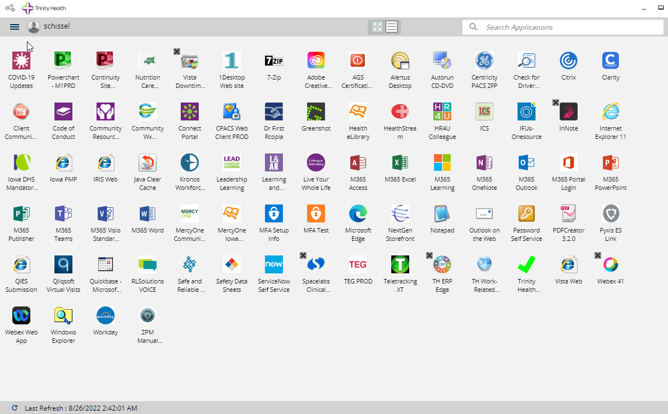

The USER ID and password for HealthStream is your Employee Number you received on Day 1 General Orientation. This number will work for both the USER ID and password the first time you log into Health Stream. Once you have logged in the first time, the system will ask you to create your own password.

**Please add your work e-mail address in Health Stream To do this, click on Profile/Personal Information/scroll down to the bottom and click on Account Settings (this is found at the very bottom on the page)**

**For colleagues with a licensure (i.e. RN, Occupational Therapist, physician) you will want to add your licensure information in Health Stream. To add this information, following the instructions below:**

1. Click on *Profile* on the task bar.
2. Click on *Licenses*.
3. Click on *Manage.*
4. Choose the correct discipline.
5. Update the expiration date.
6. Click *Save*